A Research Report on
Simulation and Investigation of Incidents using Microsoft Sentinel in Azure
______________________________________________
Submitted By:
Keshav Lamichhane, Vishal Vekariya, Meetjitendra Patel, Arishlaljibh Kakadiya
Submitted To:
Prof. Ragini Madan
Course: CST8912_010 Cloud Solutions Architecture
Date: 10th Dec 2024

Contents
Abstract 3
1. Introduction 4
1.1 Overview 4
1.2 Problem 4
1.3 Objective: 4
2. Literature Review 5
3. Methodology 6
4. Findings 6
4.1 Consequences of Brute Force Attack 6
4.2 Effective Detection of Brute-Force Attacks 7
4.3 Timely Alert Generation 7
4.4 Effective Incident Management 7
4.5 Companies using Microsoft Sentinel for Incident Detection 7
5. Implementation 9
6. Challenges 17
6.1. Data Ingestion and Normalization: 18
6.2 Detection Rule Customization: 18
6.3 Incident Investigation Complexity: 18
6.4 Incident Triage: 18
6.5 Scalability Concerns: 18
7. Challenges and Proposed Solutions Overview 18
8. Discussion 19
9. Mitigations 19
8.1 Training and Skill Development 19
8.2 Tuning and Optimization 20
8.3 Enhanced Automation 20
8.4 Proactive Monitoring 20
10. Conclusion 20
11. References: 21

Abstract
In this report, we, the students at Algonquin College: Keshav Lamichhane, Vishal Vekariya, Meetjitendra Patel, and Arishlaljibh Kakadiya, examined the importance of incident simulation and investigation using Microsoft Sentinel.
This study focuses on the ways the cloud-native Security Information and Event Management (SIEM) platform Microsoft Sentinel makes it easier to simulate and investigate security incidents. Security teams can successfully detect, analyze, and respond to high-severity incidents by utilizing Sentinel's integrated tools, analytical capabilities, and Azure connection. To improve security operations, the study describes best practices, investigation methodologies, and incident simulation techniques.

1. Introduction

1.1 Overview
The complexity and volume of cyber threats are increasing, making it more difficult for security operations (SecOps) teams to handle high-severity situations. Microsoft Sentinel, a cloud-native Security Information and Event Management (SIEM) platform offers comprehensive tools for incident detection and response. Nevertheless, a shortage of skilled analysts hinders many firms' capacity to react appropriately (Daniel, 2023).
A scalable, cloud-native Security Information and Event Management (SIEM) platform, Microsoft Sentinel integrates Security Orchestration, Automation, and Response (SOAR) features. It offers enterprises a comprehensive, intelligent solution for identifying, investigating, and reacting to cyberthreats. By giving security professionals a cohesive, all-encompassing picture of their company, Sentinel facilitates proactive threat hunting and efficient incident response (Microsoft, 2024).
Microsoft Sentinel, which is based on well-established Azure services like Log Analytics and Logic Apps, uses cutting-edge AI to improve detection and inquiry procedures. It allows for the incorporation of external threat intelligence while integrating Microsoft's own threat intelligence feed.
Sentinel's ability to simulate and investigate security incidents is the main emphasis of this paper, which also demonstrates how Sentinel helps organizations improve their security posture by enhancing threat detection and incident response.

1.2 Problem
Brute-force attacks are a persistent cybersecurity threat involving repeated, automated attempts to guess login credentials. These attacks exploit weak passwords and inadequate security measures, leading to potential data breaches, malware deployment, lateral movement within networks, resource exploitation, and operational disruptions. Even unsuccessful attempts can strain system resources and degrade performance, while the lack of immediate detection amplifies the risk (Carl Feldman, 2023).

1.3 Objective:
To demonstrate the process of simulating a brute-force attack on an Azure virtual machine (VM) and then detecting and investigating that attack using Azure Sentinel.

2. Literature Review
Gartner explained CSMA in "Top Strategic Technology Trends for 2022”. He pointed enhancing security across multiple locations and assets can be done in a flexible and scalable manner with cybersecurity mesh architecture (CSMA). It enables multiple security solutions to work together by giving important services including a shared identity system, security analysis, intelligence, automation, and triggers, along with centralized policy administration and coordination. To put it another way, CSMA makes it easier to safeguard everything, everywhere, by integrating various security tools and processes. This helps organizations increase their security (What Is Cybersecurity Mesh and How Can It Help You? | TechTarget, n.d.). By assisting businesses in putting up a multi-layered defense against cyberattacks, CSMA increases the difficulty of network breaches for intruders. A device-centric approach to security will replace the conventional perimeter model as the new benchmark for a safe and flexible cloud environment as cyber threats grow. The cybersecurity mesh market is expected to develop at a compound annual growth rate (CAGR) of 28.6%, from $0.9 billion in 2023 to $2.6 billion by 2027 (Andriy Varusha, 2024).
As published in a survey paper on cybersecurity survey, it has been mentioned that with the cybersecurity mesh transition from conventional centralized models to a decentralized structure that prioritizes the protection of individual assets independent of their location, Cybersecurity Mesh Architecture (CSMA) represents a significant leap in cloud security. Implementing a zero-trust model, CSMA treats all assets as untrusted by default, requiring continual authentication and authorization for access. This method makes it possible to take a more targeted approach to security and makes real-time modifications based on threat intelligence, which is crucial for dealing with threats that change over time in cloud environments. Through the promotion of secure collaboration and the utilization of cutting-edge technologies like strong encryption and software-defined perimeters, cloud security management, or CSMA, creates a strong security framework that improves resilience and adaptability, thereby fortifying an organization's security measures against the difficulties presented by cloud computing (RamosCruz et al., 2024).
Implementing a cybersecurity mesh promotes a zero-trust model, ensuring uniform security across all resources and helping in the defense against emerging threats. According to predictions, this strategy might enable more than half of all security events and minimize the financial effect of security incidents by 90% (Cloud Security Trends: What Is Cybersecurity Mesh?, n.d.).

3. Methodology
- Data Connector Setup: The simulation begins by installing the "Windows Security Events via AMA" data connector within the Azure Sentinel workspace. This ensures that security logs from the VM are ingested into Sentinel. The process involved navigating to Data Connectors, then Content Hub to find and install the necessary connector.[3]
- Data Collection Rule Creation: A data collection rule was created to specifically collect logs from the target virtual machine. The rule was named "windows-event" and configured to collect common security events.
- Analytics Rule Creation: A scheduled query rule, named "Brute-force detection," was created within the Azure Sentinel analytics section. This rule was designed to run every 5 minutes, checking for failed login attempts (Event ID 4625) over the last 30 minutes. The query was constructed to retrieve relevant fields like IP address, account name, and workstation name to facilitate investigation. Entity mapping was configured to improve the clarity of incident data (Carl Feldman, 2023).
- Brute-Force Simulation: The simulation involved connecting to the target VM via RDP (Remote Desktop Protocol) and inputting numerous incorrect passwords.
- Incident Investigation: After the simulation, we return to the Azure Sentinel incidents view. The "Brute-force detection" rule, triggered by the simulated failed login attempts, generated an incident which was then investigated. The incident timeline and entities showed the failed login attempts, IP addresses, and account details that are crucial in understanding the scope of the brute-force attack. The incident's status was then modified to "Benign Positive" and closed (Carl Feldman, 2023)..

4. Findings
The following are the major findings of my research:
4.1 Consequences of Brute Force Attack
A successful brute-force assault has far-reaching effects that go well beyond the compromised system:
- Operational Disruption: Businesses may encounter outages or deteriorated performance, which could impact output and client satisfaction.
- Financial Loss: Dealing with legal obligations, handling public relations, and recovering from a breach can all be very expensive.
- Reputational Damage:
- A security breach erodes confidence, harming connections with stakeholders, partners, and customers.
- Regulatory Non-Compliance: A breach may result in harsh fines for non-compliance with the strict data protection laws that apply to many industries.
Unauthorized access to sensitive personal or company data may arise from a brute force attack, which could cause identity theft, monetary losses, and business interruptions. Networks can be compromised, allowing for lateral movement or the distribution of malware like spyware or ransomware. Resources can be used for DDoS assaults or cryptocurrency mining. The attack undermines trust, harms reputations, and may result in legal repercussions for data breaches. Recovery expenses, legal penalties, and long-term vulnerabilities are all faced by victims, underscoring the urgent need for strong security measures to stop such occurrences (Brute Force Attacks Explained: Types, Risks, and How to Stay Safe, 2024).

4.2 Effective Detection of Brute-Force Attacks
The simulation and investigation of attack using Microsoft sentinel highlights the significance of strong security measures to thwart unwanted access. The "Windows Security Events via AMA" data connector successfully ingests security event logs from the virtual machine into the Azure Sentinel workspace, confirming its capability to collect critical security data for monitoring and analysis (Carl Feldman, 2023).
4.3 Timely Alert Generation
The custom-built scheduled query rule, designed to detect brute-force attacks, effectively identified the pattern of failed login attempts. Alerts and corresponding incidents were generated promptly, validating the rule's real-time threat detection capability.
4.4 Effective Incident Management
The incident management features of Azure Sentinel proved effective, including options to change incident status, update classification, and assign incidents to team members. These features support streamlined workflows for incident response.
4.5 Companies using Microsoft Sentinel for Incident Detection
Organizations from various industries, including finance, technology, wholesale, and government, rely on Microsoft Sentinel for security monitoring and threat detection. Prominent businesses that rely on Microsoft Sentinel to protect their vital digital infrastructures include IBM, Capital One, and Rockwell Automation (Companies Using Azure Sentinel, Market Share, Customers and Competitors, n.d.). More than 3,100 businesses use Microsoft Sentinel, with a notable presence in the US in the IT and services sector, according to statistics from Enlyft. EPAM Systems Inc., RedCanary.ca, Cohesity, Accenture PLC, and Cognizant Technology Solutions Corp. are notable companies. These businesses use Microsoft Sentinel's cloud-native SIEM features, which include scalability, enhanced threat detection, and integration with pre-existing security solutions, to improve their security operations. This extensive use demonstrates how well Microsoft Sentinel delivers all-encompassing security solutions across various sectors (Azure Sentinel Commands 0.06% Market Share in Network Security, n.d.).
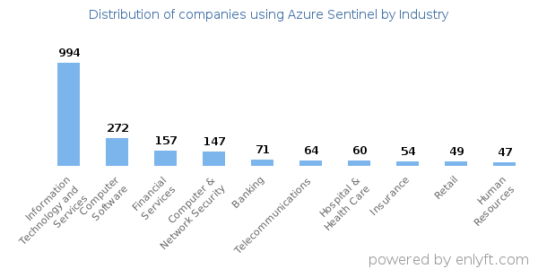
Image source: https://enlyft.com/tech/products/azure-sentinel?
Below is the list of companies using Microsoft sentinel in table format (Azure Sentinel Commands 0.06% Market Share in Network Security, n.d.).
Company Name | Industry | Usage of Microsoft Sentinel
Optiv | Technical (Software Development) | Optiv uses Sentinel for monitoring potential cybersecurity threats, ensuring the security of its development processes and applications.
Capital One | Finance (Banking) | Sentinel supports Capital One in detecting threats such as phishing and unauthorized access, ensuring compliance with banking regulations and protecting sensitive customer data.
Icertis | Technical (Software Manufacturing) | Icertis leverages Sentinel to secure its software manufacturing operations, focusing on detecting vulnerabilities and ensuring intellectual property protection.
IBM | Technical (Software Development) | IBM utilizes Sentinel for comprehensive threat monitoring across its enterprise systems, ensuring quick response to advanced threats and minimizing risks to its operations.
Rockwell Automation | Wholesale (Electronics & Manufacturing) | Sentinel enables Rockwell Automation to protect its industrial systems and IoT devices from cybersecurity threats, maintaining uninterrupted operations.
CoreCivic | Government | CoreCivic uses Sentinel to monitor for and respond to threats, ensuring the security of its government-focused operations and compliance with strict data protection regulations.

5. Implementation
Sentinel data collection: Using Sentinel's agent-based monitoring, we configured data connectors to record Windows security events from the Azure virtual machine. This made it possible for Sentinel's Log Analytics workspace to receive real-time log collection of security events, including unsuccessful login attempts (Event ID 4625).
Sentinel Analytics Rule Creation: By analyzing Windows security events and concentrating on unsuccessful login attempts, we created a custom rule to identify brute-force assaults. Using MITRE ATT&CK strategies, this rule was set up to detect Credential Access, Privilege Escalation, and Initial Access.
Attack Simulation: Using random passwords, several unsuccessful login attempts were made on the Azure virtual machine to simulate a brute-force attack. Sentinel monitored the pertinent failed login events that resulted from this.
By leveraging Microsoft Sentinel, we aim to generate incidents that highlight various stages of an attack, such as Privilege Escalation, Initial Access, and Credential Access, all of which are recognized as part of the MITRE ATT&CK framework. This simulation will allow us to illustrate how Zero Trust controls and monitoring tools like Azure Defender and Sentinel can be used to detect and respond to security threats in real time, even within the limitations of our student Azure subscription.
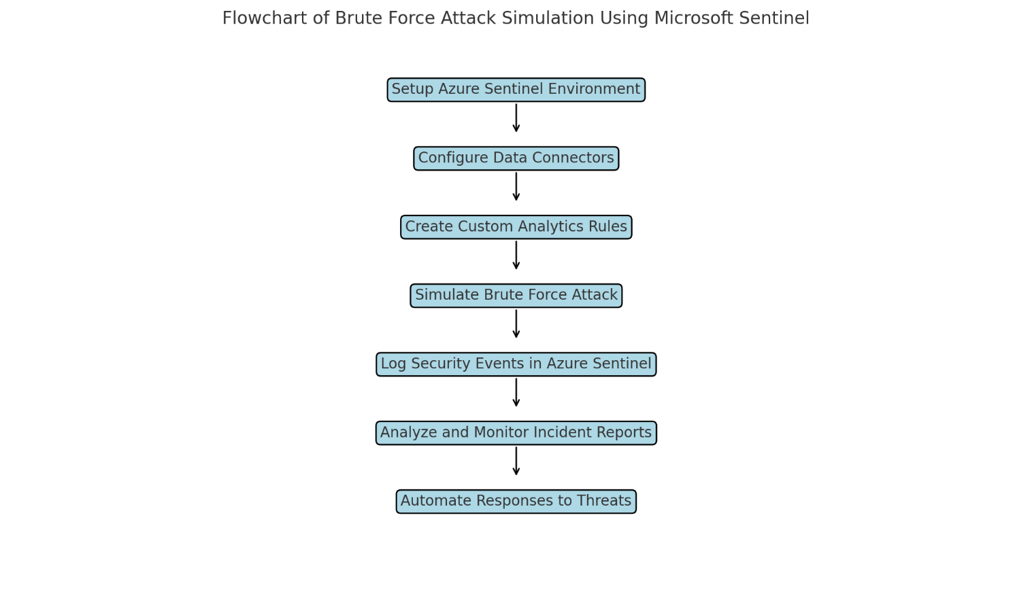

Simulation of Incident using Microsoft Sentinel:
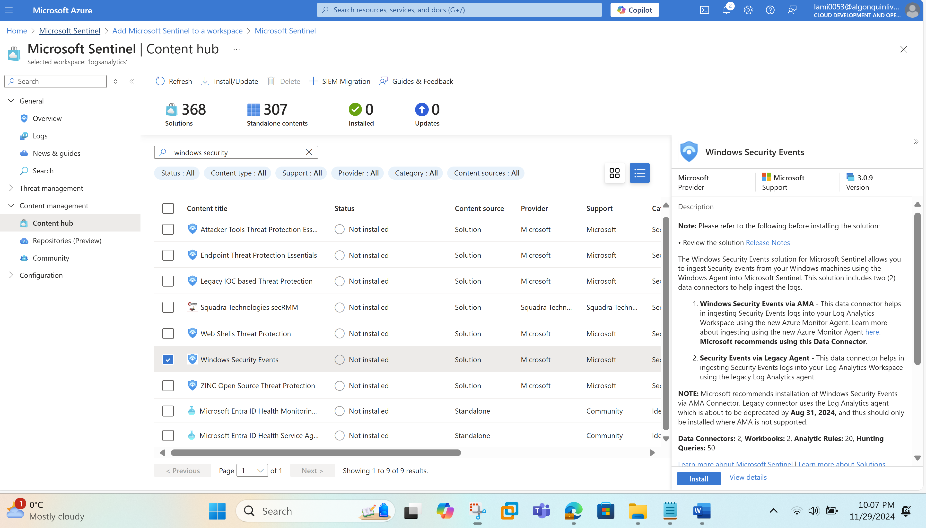

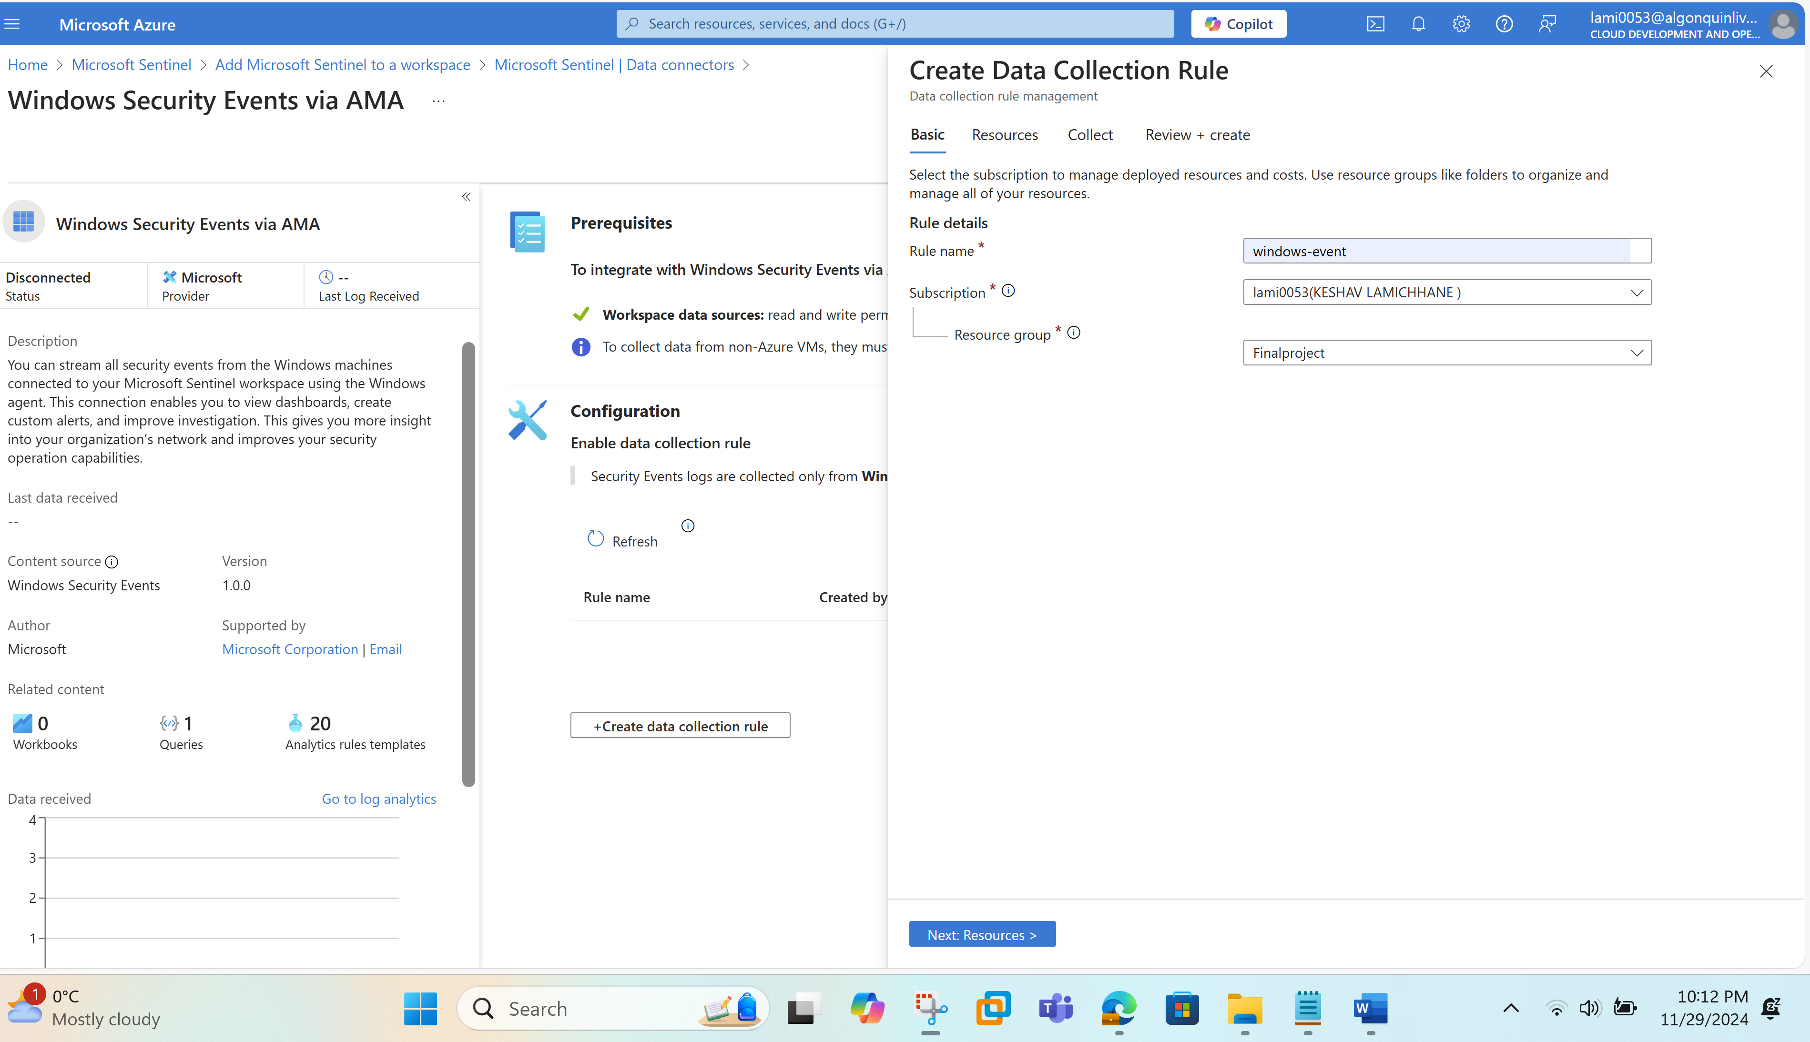
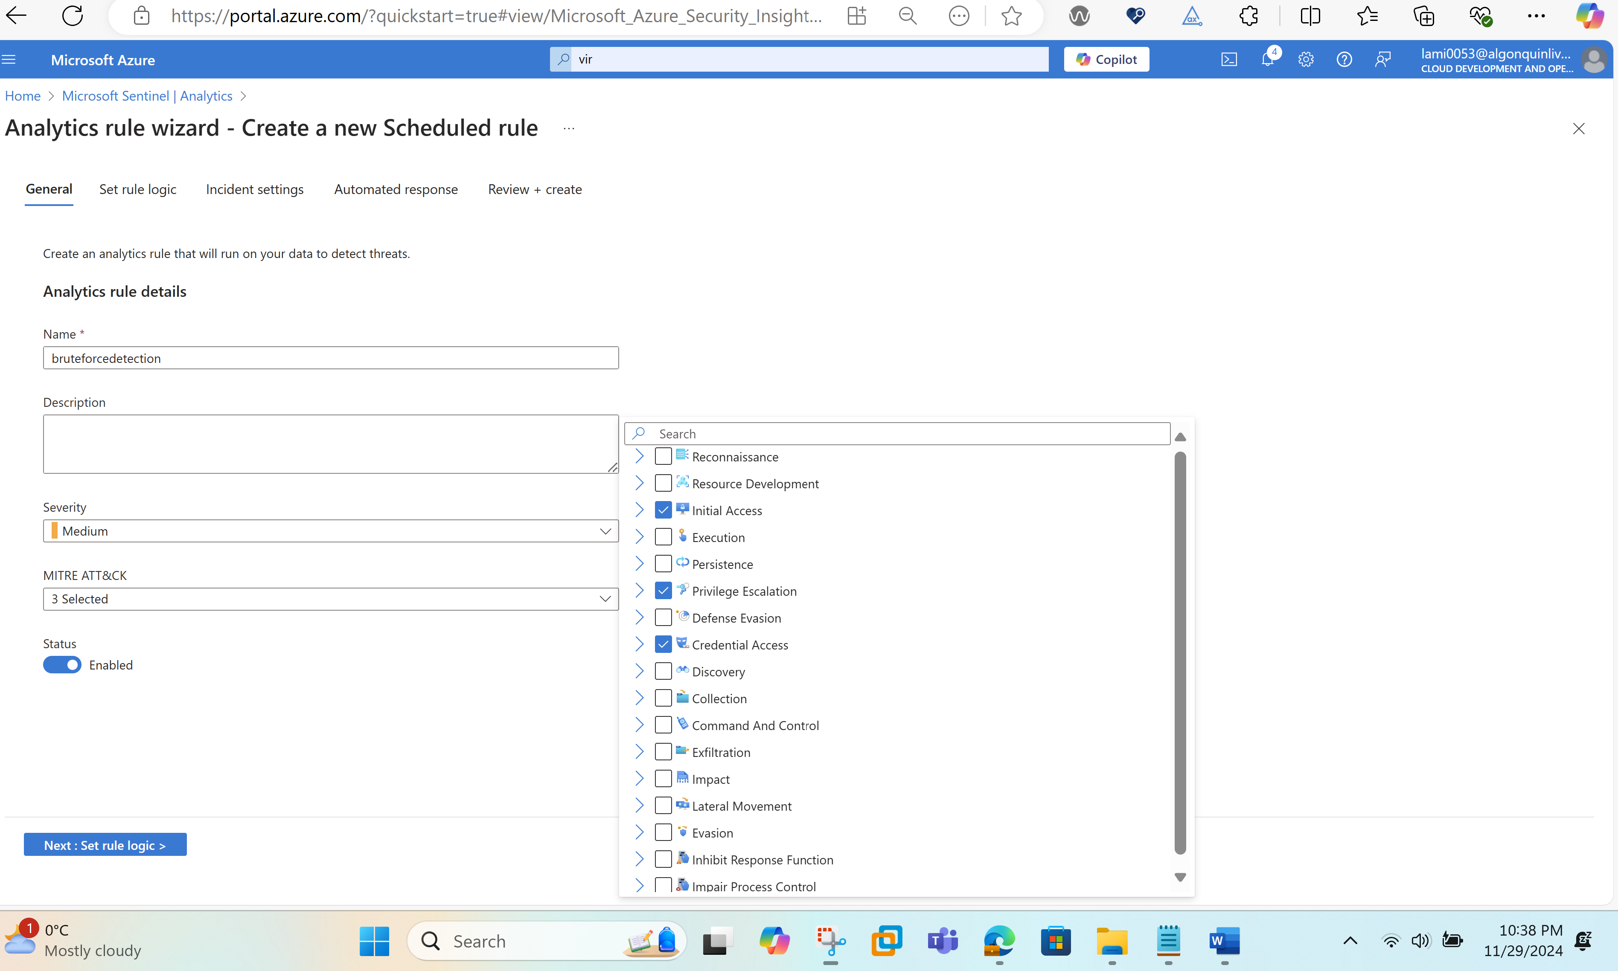

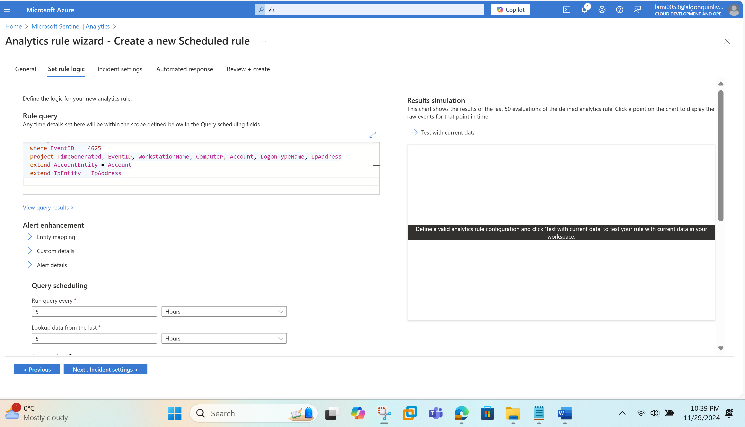
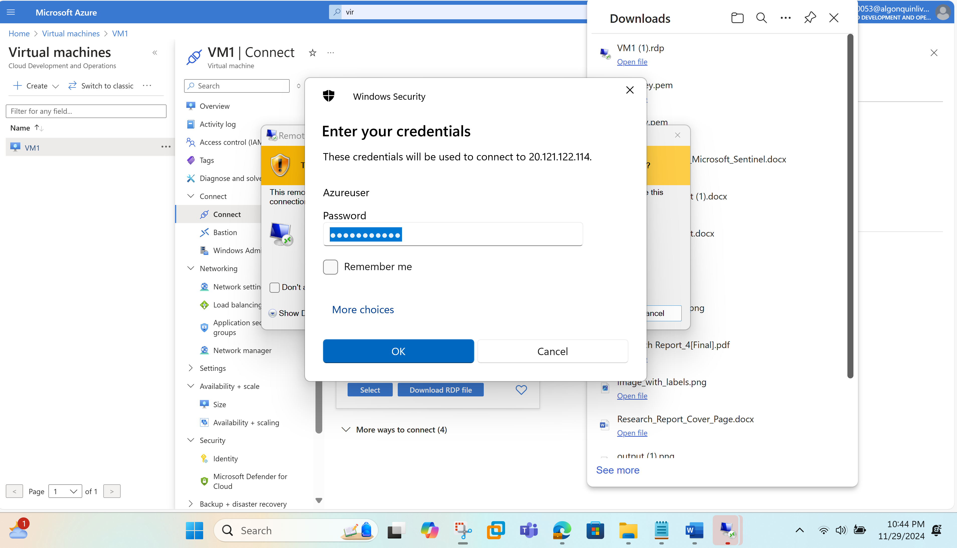
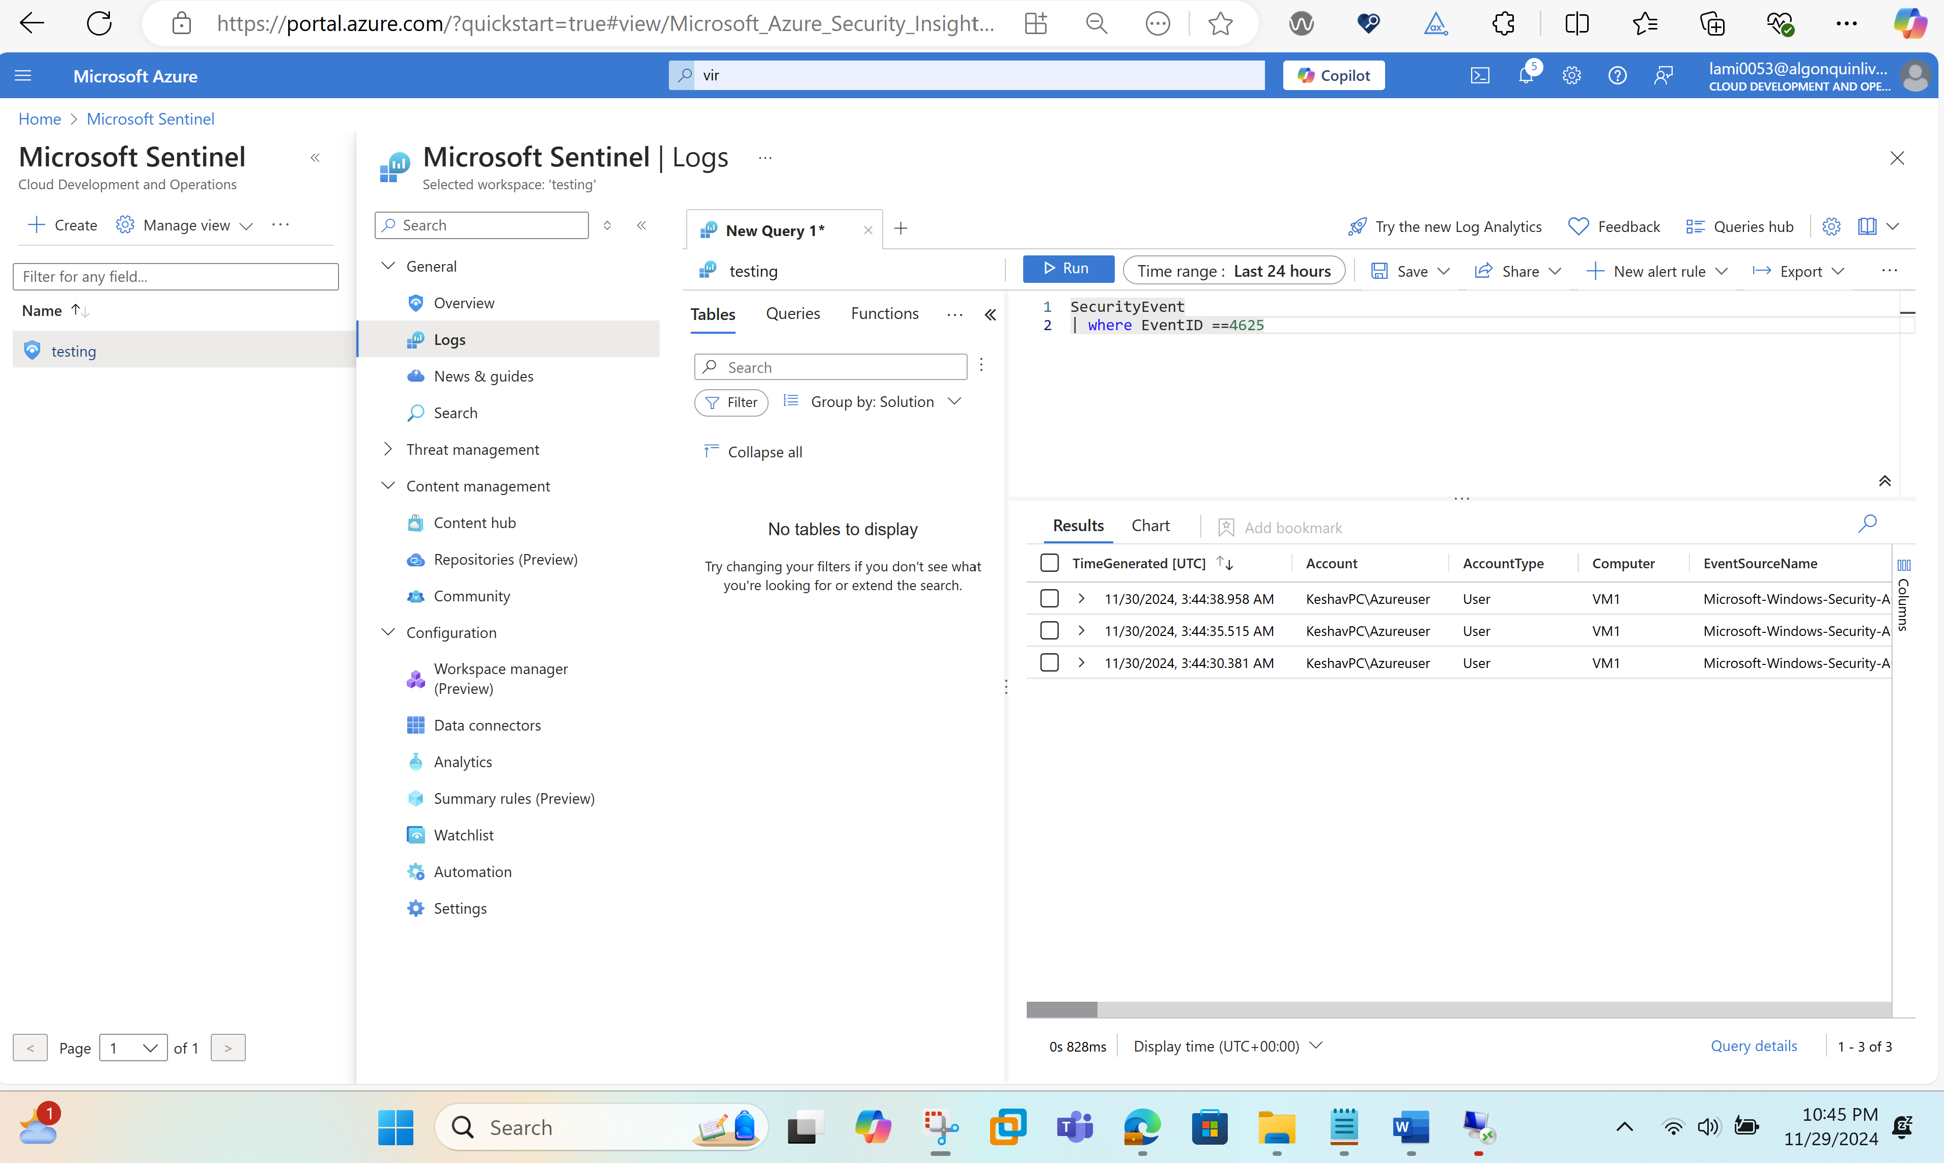
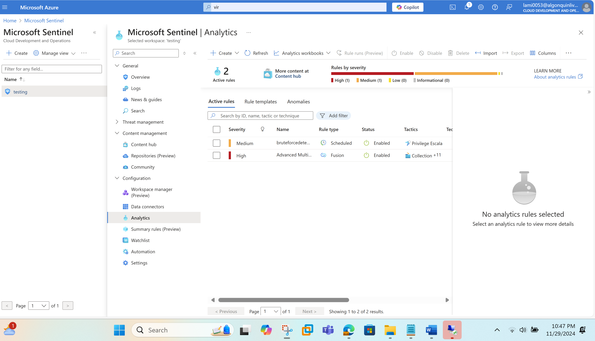
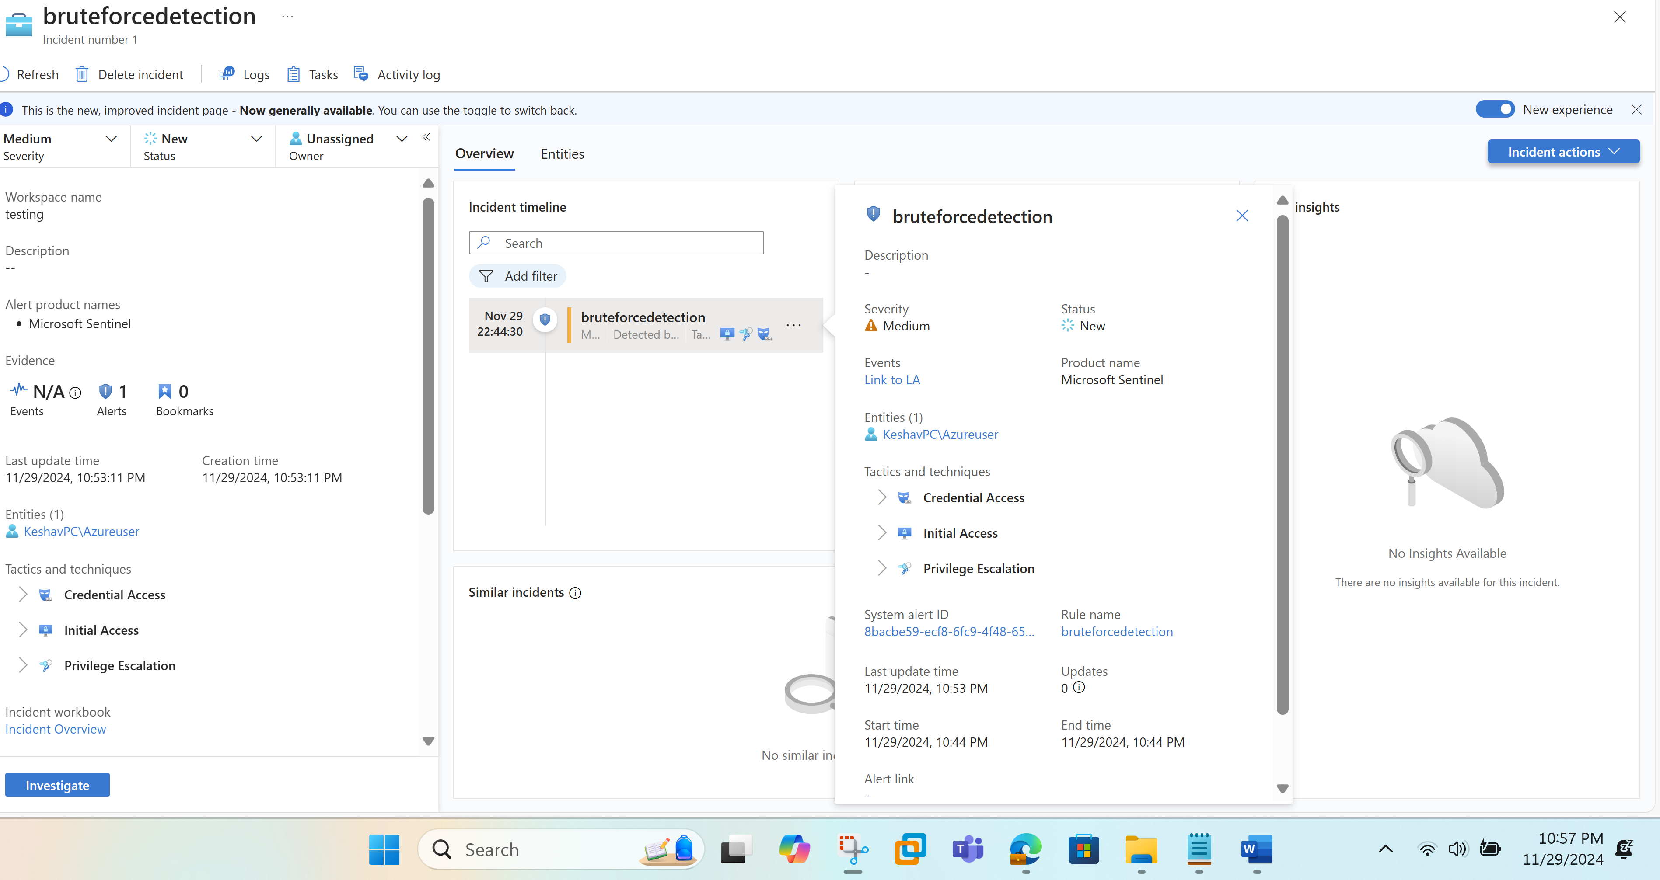
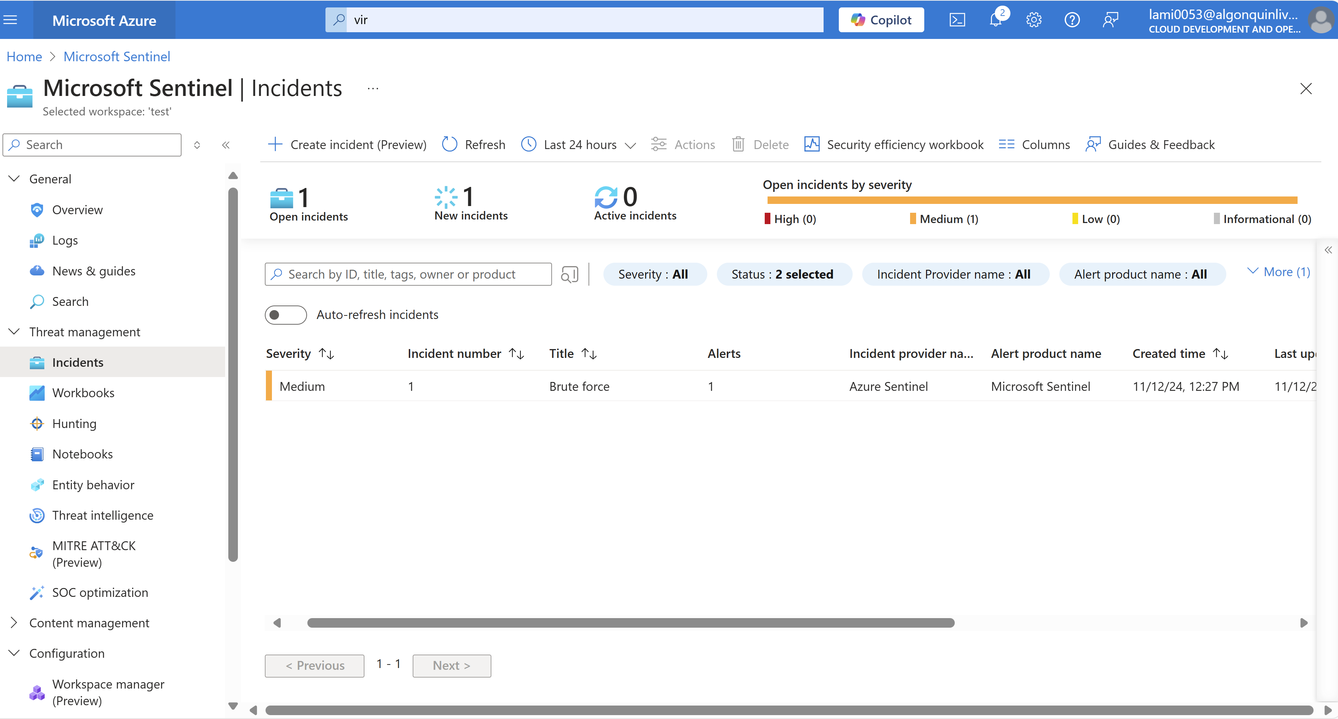
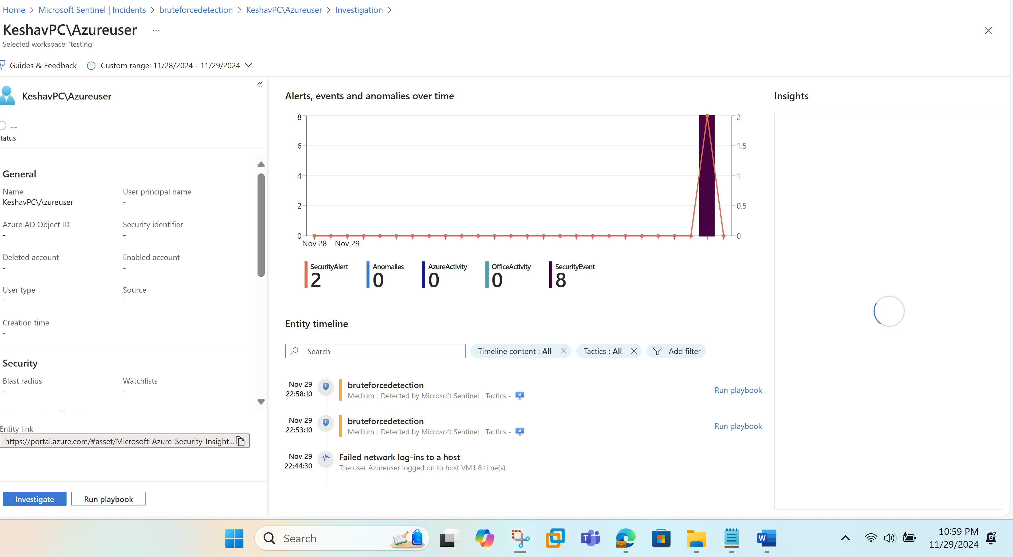

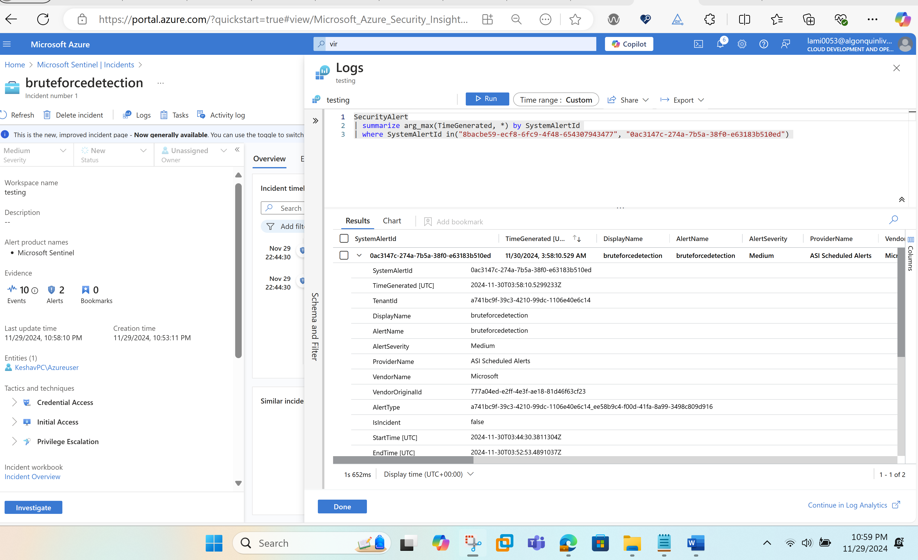
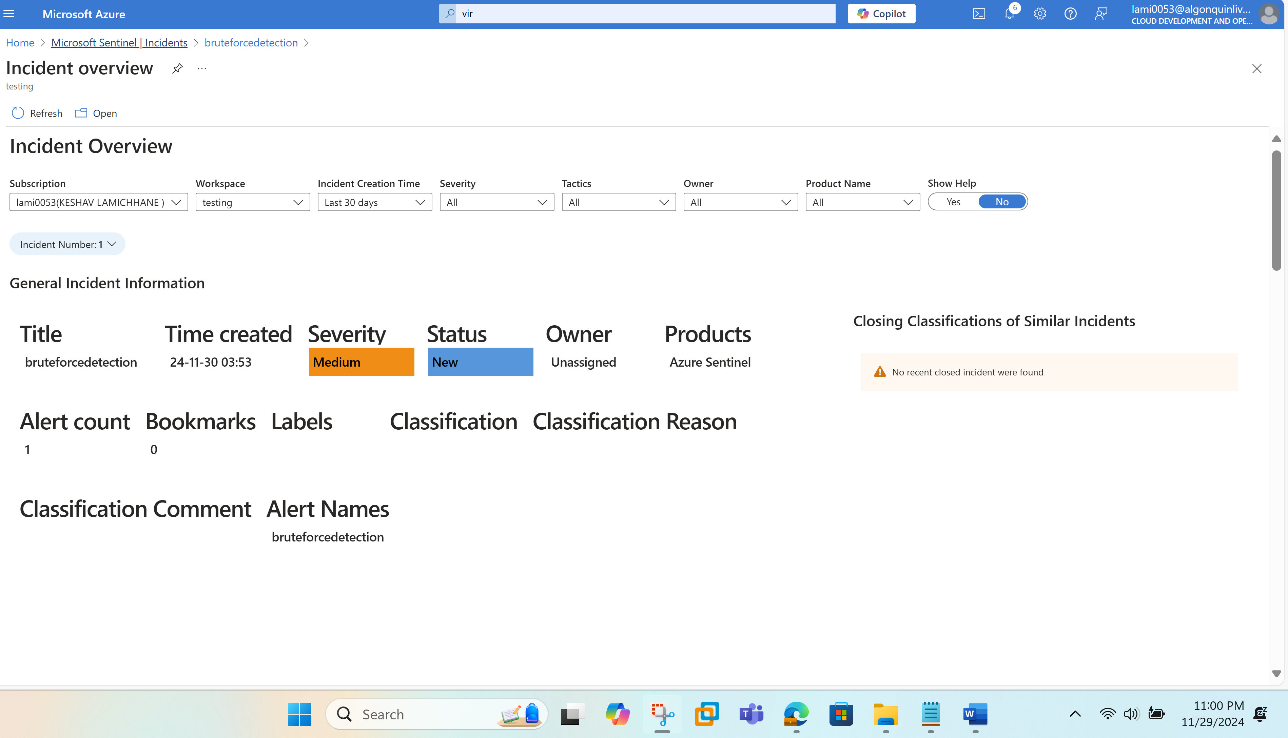
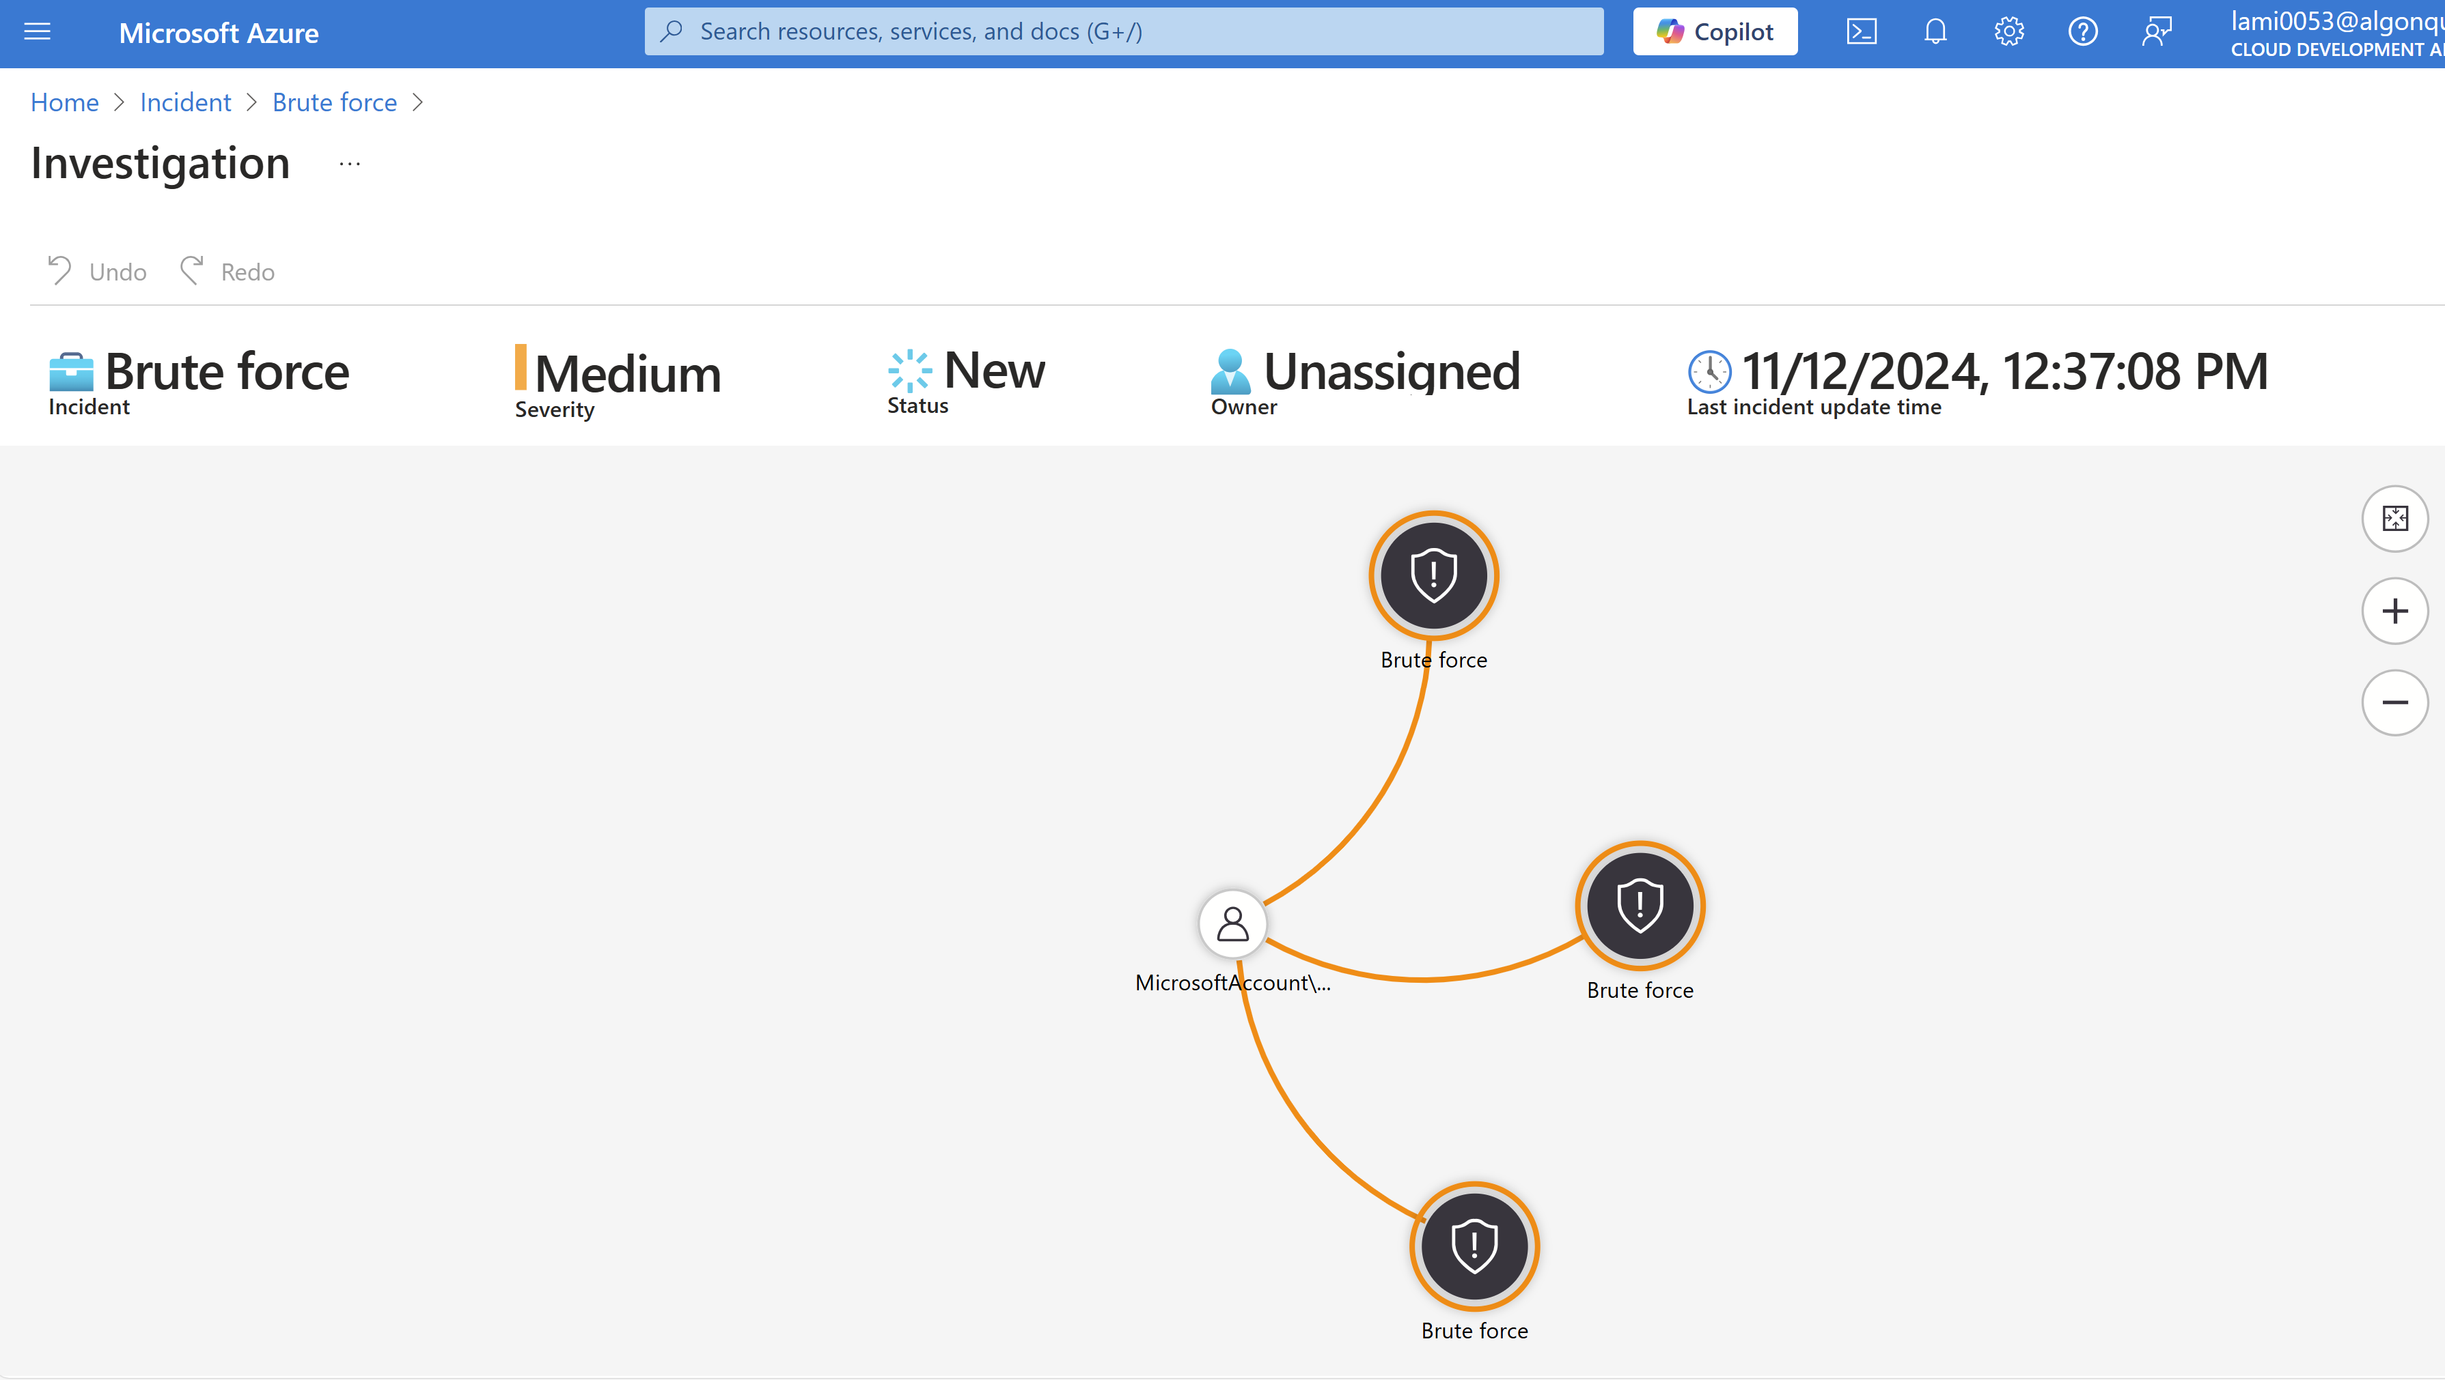

6. Challenges
Implementing Microsoft Sentinel in Azure for incident simulation and investigation presents several challenges:
6.1. Data Ingestion and Normalization: To guarantee consistent analysis when integrating several data sources into Sentinel, appropriate ingestion and standardization are necessary. Particularly when working with several log formats and data kinds, this procedure might be complicated (YanivSh, 2022).
6.2 Detection Rule Customization: Being proficient in Kusto Query Language (KQL) is necessary for creating and optimizing detection rules. Developing efficient rules is crucial for reducing false positives and accurately detecting threats. Creating effective KQL queries requires a good understanding of the language and the specific event logs. The process of crafting the query for brute-force detection, while seemingly straightforward in the video, might be challenging for those unfamiliar with KQL syntax and the schema of the security logs (rudneir, 2023).
6.3 Incident Investigation Complexity: Investigating incidents involves navigating through multiple alerts and correlating them to understand the full scope of an attack. We can say that process can be time-consuming and requires a comprehensive understanding of the incident investigation tools within Sentinel (yelevin, 2023).
6.4 Incident Triage: Even with alerts, the investigator (security team) still needs to triage and investigate each incident to determine its true nature (false positive or a real attack). This adds to the workload and emphasizes the human element in security response.
6.5 Scalability Concerns: Scaling the solution across a large environment with numerous VMs would significantly increase the volume of logs and the complexity of alert management.

7. Challenges and Proposed Solutions Overview
Challenge | Proposed Solution
Data Ingestion and Normalization | Ensure consistent data ingestion by utilizing standardized connectors provided by Microsoft Sentinel. Implement a centralized data management framework and use Log Analytics for normalizing data from multiple sources. Provide training on log schemas and standardization techniques.
Detection Rule Customization | Conduct training sessions on Kusto Query Language (KQL) to enhance proficiency among team members. Provide access to pre-built detection rule templates and leverage Microsoft Sentinel’s documentation and community resources for creating effective detection rules.
Incident Investigation Complexity | Use Sentinel’s incident investigation timeline and entity mapping features to streamline investigations. Implement automated workflows to correlate alerts and reduce manual effort during incident investigation. Employ playbooks using Azure Logic Apps for repetitive tasks.
Incident Triage | Develop and deploy an automated triage system using Sentinel’s SOAR capabilities to classify and prioritize alerts. Implement clear guidelines for incident categorization to minimize manual effort and improve efficiency.
Scalability Concerns | Use Sentinel’s built-in scalability features and configure retention policies to manage large volumes of logs. Employ data partitioning and use scalable storage options like Azure Data Explorer to handle increased data loads effectively.

8. Discussion
This study highlights the practical application of Microsoft Sentinel for detecting and investigating cybersecurity incidents, with a specific focus on brute-force attacks. The challenges identified underscore the complexity of modern security operations, which require both technical expertise and strategic implementation of tools. Proposed solutions such as enhanced training, leveraging automation, and scalability adjustments provide actionable steps to mitigate these challenges. By adopting these practices, organizations can enhance their incident response capabilities and security posture.
Microsoft Sentinel's adaptability and connectivity with the larger Azure ecosystem highlight its usefulness in dynamic and hybrid settings. However, resolving user-specific issues, especially those related to scalability and customization, is essential to the implementation's success. Organizations may optimize the platform's potential by cultivating a culture of ongoing learning and utilizing community-driven best practices (cwatson-cat, 2024).

9. Mitigations

8.1 Training and Skill Development
- Provide comprehensive training on KQL and rule configuration for security analysts.
- Must leverage Microsoft’s official documentation and tutorials for skill enhancement.

8.2 Tuning and Optimization
- Regularly review and refine detection rules to minimize false positives.
- Use baseline analytics to tailor alerts to the organization’s environment.

8.3 Enhanced Automation
- Develop and test robust playbooks for common incident types to reduce manual intervention.
- Utilize adaptive automation to respond dynamically to emerging threats.

8.4 Proactive Monitoring
- Set up continuous monitoring dashboards for real-time threat visibility.
- Schedule periodic threat-hunting sessions to uncover hidden risks.

10. Conclusion
Microsoft Sentinel's efficacy as a cloud-native SIEM platform is demonstrated by the simulation and research done using it. Sentinel facilitates effective incident management and real-time detection by utilizing tools like as data connectors, analytic rules, and SOAR capabilities. Notwithstanding obstacles like scalability, data standardization, and customization of detection rules, the suggested solutions guarantee that these problems can be methodically resolved. A strong, scalable, and intelligent platform for protecting digital assets and boosting resilience against new threats is available to organizations that use Microsoft Sentinel.

11. References:
cwatson-cat. (2024, June 28). Best practices for Microsoft Sentinel. Microsoft.com. https://learn.microsoft.com/en-us/azure/sentinel/best-practices?
Daniel, T. (2023, August 13). Microsoft Sentinel: Using Azure OpenAI to assist Security Analyst with incident respond and investigation using Logic App. Medium. https://medium.com/@daniel_toh/microsoft-sentinel-using-azure-openai-to-assist-security-analyst-with-incident-respond-and-a23be30319e8
Microsoft. (2024, May 21). What is Microsoft Sentinel? Learn.microsoft.com. https://learn.microsoft.com/en-us/azure/sentinel/overview?tabs=azure-portal
Carl Feldman. (2023, September 12). Simulating A Brute Force Attack & Investigating With Microsoft Sentinel. YouTube. https://www.youtube.com/watch?v=wSqBiFz1hoA
Brute force attacks explained: types, risks, and how to stay safe. (2024, November 13). Malwarebytes. https://www.malwarebytes.com/cybersecurity/basics/brute-force-attack
‌Companies Using Azure Sentinel, Market Share, Customers and Competitors. (n.d.). Discovery.hgdata.com. https://discovery.hgdata.com/product/azure-sentinel
‌Azure Sentinel commands 0.06% market share in Network Security. (n.d.). Enlyft.com. https://enlyft.com/tech/products/azure-sentinel
YanivSh. (2022, August 12). New ingestion-SampleData-as-a-service solution, for a great Demos and simulation. TECHCOMMUNITY.MICROSOFT.COM. https://techcommunity.microsoft.com/blog/microsoftsentinelblog/new-ingestion-sampledata-as-a-service-solution-for-a-great-demos-and-simulation/3598500?
rudneir. (2023, August 14). Implementing Microsoft Sentinel and Two simulated threats from scratch! Then see Sentinel in action! TECHCOMMUNITY.MICROSOFT.COM. https://techcommunity.microsoft.com/blog/fasttrackforazureblog/implementing-microsoft-sentinel-and-two-simulated-threats-from-scratch-then-see-/3899262?
yelevin. (2023, August 30). Incident investigation with Microsoft Sentinel in the Azure portal. Microsoft.com. https://learn.microsoft.com/en-us/azure/sentinel/incident-investigation?

‌

‌

‌
‌

